PROJECT 2 – Password Security & Cracking Analysis

Abstract
This project demonstrates password security analysis in a controlled environment using Kali Linux, OpenSSL, HashID, Crunch, and John the Ripper.

Objectives
- Understand password security
- Generate SHA-256 hashes
- Identify hash types
- Generate a wordlist
- Analyze hashes with John the Ripper

Practical Summary
- Verified required tools.
- Created passwords.txt with sample passwords.
- Generated SHA-256 hashes into hashes.txt.
- Identified possible hash type using HashID.
- Generated a custom wordlist using Crunch.
- Analyzed hashes using John the Ripper.
- Observed 4 password hashes cracked in the controlled dataset.
Figure 1
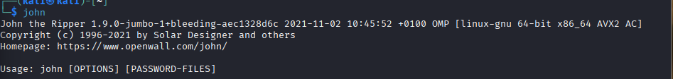
Figure 2
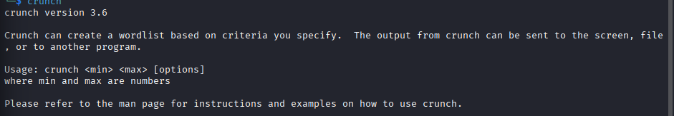
Figure 3
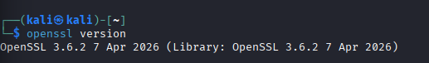
Figure 4
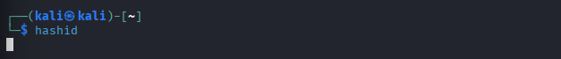
Figure 5
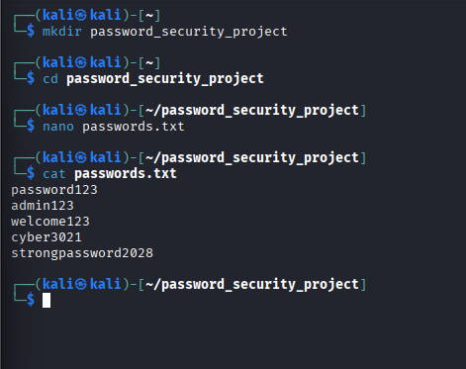
Figure 6
Figure 7
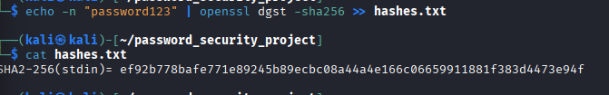
Figure 8
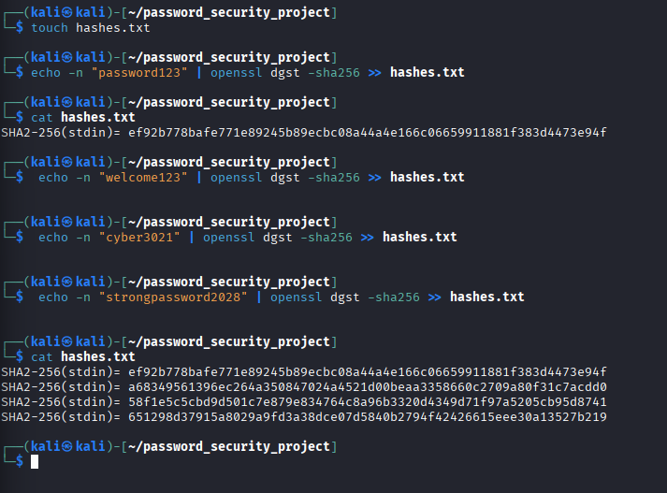
Figure 9
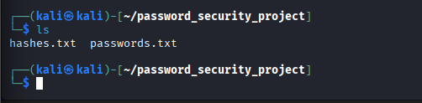

Conclusion
The project shows that predictable passwords included in a known test wordlist can be matched to their hashes, emphasizing the importance of strong unique passwords.

